Into the Story: Living the Rhythms of the Christian Calendar
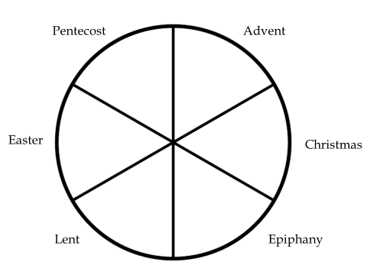

Anticipation Celebration Proclamation
Advent Christmas Epiphany
Lent Easter Pentecost

“I want the Christian story to shape everything I do, even how I reckon time.
I want it to be truer and more essential to me than school’s calendar,
or Hallmark’s calendar, or the calendar set by the IRS.
I want the rhythms of Advent, Christmas, Epiphany, Lent, Easter, Pentecost
to be more basic to my life than the days on which my quarterly estimated taxes are due.”
-Living the Christian Year, 9-10 in Forward by Lauren Winner

“How does time bring us closer to God? The Christian year is a means by which we relive for ourselves all that matters of salvation history. When we recall the past events of salvation, they come alive in their present power to save. Our acts of remembrance bring the original events back to us with all their meaning. And so we continue to “proclaim the death of the Lord, until he comes” (1 Cor 11:26). The various acts of rehearsing salvation history give us anew the benefits of what God has done for us in these past events. Christ’s birth, baptism, death, resurrection, and so on rare all given to us again for our own appropriation through corporate recalling of these events so as to make them again present. These events become no longer simply detached data from the past but part of our own personal history as we relive salvation history through rehearsing it in our worship. Thus Christ dies in our consciousness every Good Friday. And every Easter and every Lord’s Day we are witnesses to the resurrection.

The Christian year becomes a vital and refreshing means through which God is given to us. It is a giving that is never exhausted. Each time, the year, the week, and day push us a bit deeper into encounter with God. We perceive one aspect of Christ’s being baptized this year, another next year, but never do we touch bottom. So the liturgical year is a constant means of grace through which we receive God’s gifts to us.

The year of grace is about what God does for us, not our efforts. The whole structure calls attention to God’s work, not ours. And God’s work is made known in differing ways through the changing events and needs of every time and place in which Christians worship.”
–James F. White, Introduction to Christian Worship, p. 73-74

